(Approx. 1,849 words)

Paintshop™ Pro X4
Reviewed by Clint Tinsley, Editor, Idaho PCUG
October 2011 issue, Bits and Pieces
http://idahopcug.apcug.org/
c_tinsley (at) msn.com

Extensively reworked with new defined workspaces and a number of new features, Corel released Paintshop™ Pro X4 in September 2011. With new features and enhancements totaling over 75, it is awesome. Both the standard and Ultimate additions are available for purchase from the Corel Website. There is also a free 30 day trial available for downloading. At http://www.corel.com/paintshop, you can find more information about Paintshop™ Pro X4 along with a link for downloading the 30 day trial. There are also a several new videos on You Tube showing off the new features and enhancements that could be the subject of a book; http://www.youtube.com/watch?v=R1Qzx5G-Nhc or just search YouTube for “corel paint shop pro x4” where you will find a wide selection of videos.

X4 New Workspaces
The graphic shows the new workspaces in X4 which are Manage (Photo Manager), Adjust (replaces what was the Express Lab in X3) and the Edit workspace, formally “Full Edit” in X3. The changes go beyond just the name changes as the tools have been improved and access is friendlier. In this first graphic, you see one of the new tools, Fill Light/Clarity, available as an adjustment. This new tool allows you apply fill light to dark areas of the photo, drawing out the detail, along with a clarity adjustment to sharpen up those areas. The Adjust panel is new and occupies only the left side of the workspace. This is important with the new 1368X766 laptop screens in that it doesn’t use the top and bottom space, giving you more room to see and work on your photo as well as room for the Organizer.
Also, in this view, you are provided the camera’s exif information from the photo just below the histogram. Next up is a small tool bar providing access to the Crop, Straighten, Red Eye, Makeover Tools (Blemish Remover, Toothbrush Teeth Whitener, Eye Drop for the Eyes, Suntan (no tanning salon here!), and Thinify ( no exercise or dieting required), and finally the Clone Brush. Clicking on any of these tools or the tools in the list will result in a window opening such as you see for the Smart Photo Fix. Other tools in Adjust are Color Balance, Brightness/Contrast, Local Tone Mapping, High Pass Sharpen and Digital Noise Removal. Then under the photo space are some additional tools for rotating the photo and sharing. The bottom is the Organizer with tools for quickly opening photos for adjusting.

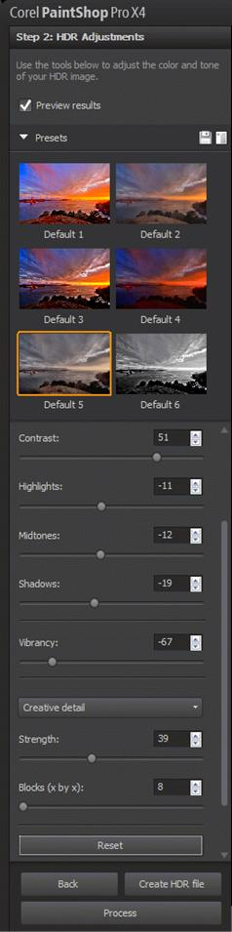
Many of the tools that were available in X3 have been greatly enhanced. An example of this is the HDR tool which is being touted as a new in X4, was available in X3, but in X4, there is a complete new tool set for HDR. With X4, there are many adjustments you can make to the composition and creating a true photographic work of art. HDR is short for High Definition Resolution and takes advantage of new digital cameras that allow you to “auto bracket” a shot where the camera takes a sequence of photos of the same shot but with different exposure values (ev units) such as -3, 0, and +3 with the result that you get a picture that is underexposed (-3), one normal, and one +3, slightly overexposed where the sky and bright area will be blown out but you will have more detail in dark areas. The –3 under exposure preserves detail in the bright areas so that when you combine the three photos using HDR, you get a well detail (high resolution) photo with good detail in all areas of the photo from dark to light. Again, this HDR Adjustment panel only occupies the left side of the workspace. One other point to be made here is that X4 is also 2 monitor friendly so that you can move the editing workspaces to a second monitor for more room on your desktop.

More New Tools

Photo Blend! This new tool provides you the ability “blend” two photos together (assuming similar content), taking the best from the two to make one composite photo. An example of this is family photos, particularly those with children in them or other members that may not be well behaved. Using Photo Blend, you can selectively “brush out” and “brush in” the desirable elements to make a great photo. Best use of this tool does require that the photos be very close in composition such a being taken using a tripod or at least a very stable hand on the camera.
New also is the Selective Focus tool. Using this tool, you can blur the photo while keeping focus on an area of the photo that you want to draw out; this is different than “depth of field” where you bring focus to only the foreground or a specific object of focus. Using this tool, you can define the area to remain in focus along with blur amount, edge softness (hardness), and color saturation.

Vignette is another new tool. Using this tool, you can “vignette” an area that remains in focus while the surrounding area is made to blur and fade to black (or degree of darkness) with adjustments for amount of blur, amount of glow, and again, the feather of the edge in defining the hardness of the edge.

Many areas have been improved or enhanced in X4. One of those areas is the Camera RAW lab for working with your Camera RAW photo images. 16 bit color support has been expanded to over 20 tools resulting in better detailed corrections using tools such as the Scratch Remover, Object Remover, some brushes, and the Background Eraser.

Paintshop™ Pro X4 is leaner and meaner now; even the install file is smaller. X4 has over 75 performance improvements including GPU optimizations which are noticeable with many operations now done in real time. Perceivable improvements in operations like noise reduction and Camera RAW file decode operations.

Learning Paintshop™ Pro X4
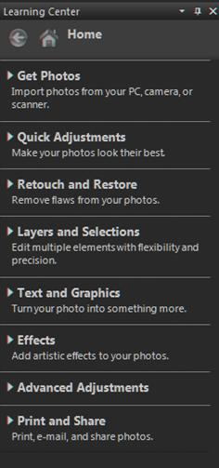
Starting with the Getting Started Welcome or splash screen, help in learning X4 is always close by. On the Welcome screen, are links to information on using the new Manage, Adjust and Edit workspaces plus links to The Digital Workflow and Learning Tools. In the Edit workspace, you will find the Learning Center shown here. The choices there will take you to the tools for the activity and guidance on using them. The F1 Help key is well thought out in that if it senses there is an Internet connection, you get the latest help information from the Corel website and if you are not connected, it opens same help information from a local copy that was current at installation time. Another source of help is the Help on the Menu bar where you will find other help resources. There is also a 194 X4 User Guide PDF available. And there are the numerous videos posted on You Tube that I mentioned at the start of the article which you can find with a simple “Corel Paintshop Pro” search on You Tube at http://www.youtube.com.

What’s in the Box?

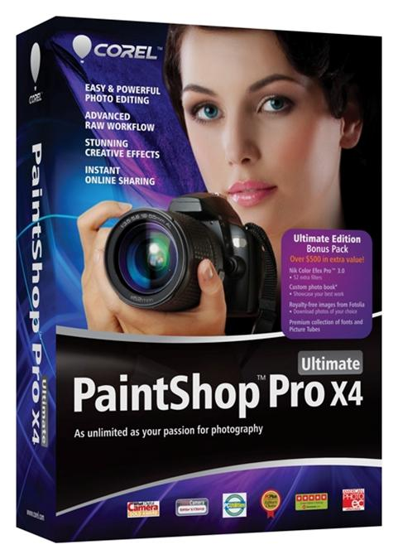
Corel has a number of offerings and upgrade paths available to both new and registered users to get to X4. I initially did the standard upgrade download from an Email that I received as a registered user. My download including the X4 software, User Manual PDF eBook, the KPT plug-in filters “extras” and a copy of WinZip 15. All for $49.99 ($10 off regular price). For $20 more, there is the Ultimate edition where you also get Nik® Color Efex Pro™ 3.0 photo effects and filters, a $200 value, royalty-free images from Fotolia, also a $200 value, a Custom photo book from Blurb®* ($35 value), and a collection of Free Picture Tubes™ . I haven’t seen retail or street prices yet for Paintshop™ ProX4 but expect them to be in the $60 and $80 ranges for Standard and Ultimate respectively. And if history is any indicator, Corel may change it product offerings as to what is in the box. In the past, I have seen them include a 2 GB USB drive and a free eBook.

System Requirements
- Microsoft® Windows® 7, Windows Vista® or Windows® XP, with latest service packs installed (32-bit or 64-bit editions).
- 1.5 GHz processor (2 GHz or faster recommended).
- 1 GB RAM (2 GB RAM or higher recommended).
- 1 GB free hard drive space (2 GB or greater recommended).
- 1024 x 768 resolution, 16-bit color display.
- Windows-compatible CD-ROM drive for installation.
- Internet connection required to post photos online and download program updates.

Concluding Notes
I am quite impressed with Paintshop™ Pro X4 as issues I had with X3 have been resolved including cropping operations and printing. I can do just about everything I want to do with a photo inside X4. PSP has the all the tools that it has had over the years including extensive layer support where you can preserve the original photo as the background layer and overlay it with multiple layers in adjusting the various objects within the photo as well as adding new objects such as content from other photos, picture tubes, picture frames, and text on top of the original photo. You can also adjust the visibility or transparency of those layers.

Another feature I like is the Crop to New Image where when I can scan in multiple pictures at the same time and use this feature to automatically create a new file from the cropped area and keep the original full scan open, so individual photo files can be easily separated from the scanned image.

One feature I am not crazy about is Smart Carver™ which is supposed to seamlessly remove foreground objects from your photo. It is not seamless in its operation, it does leave a perceivable line in the picture, as it works by essentially creating a “fold” in the picture where the object was which can reduce the width or height of the picture if you don’t compensate. Also, you have to mark the areas you don’t want “distorted” by the operation. The “Art” in removing an object is to replace the background behind the object being removed so that it truly “seamless.” This can be easily achieved if you have two similar photos, one with the object and one with the background so that you can clone the background. Other approaches similar to Smart Carver™ found in other programs also fall short. I have found one tool that can “synthesize” the background and when used with the clone tool comes very close, the GIMP editor and it is free.

Other Paintshop™ Pro tools that I like which are very effective and easy to use include the Smart Photo Fix, Straighten tool, Perspective tool, fishbowl correction, Clone, Makeover tools and the color changer.

I highly recommend upgrading to X4 even if you have X3 because of the redesigned work spaces are better organized and laptop friendly in use of the desktop plus all those new features and enhancements to existing features.

